Gulf Breeze Elementary
Music Department

Christy Stump, Teacher
stumpc@santarosa.k12.fl.us
https://gbesmusic.weebly.com
“All children can be taught to be tuneful, beatful, and artful.” –John Feierabend
____________________________________________________________________________________________

August 17, 2018
Dear Parents and Guardians,

Fourth grade students are going to be applying their musical skills through playing recorders this year. This will be an exciting opportunity for students to experience music hands on! For sanitary reasons, each student is asked to provide their own recorder and bring it to class each day they have music. If your child already has a quality 3-piece recorder, they may certainly use it for music class. The music department will be ordering Yamaha YRS24B 3-piece (tunable) soprano recorders.

We will be participating in Recorder Karate which rewards a colored belt that each child may display as they reach each milestone, much like belts are earned in Karate. Gulf Breeze Elementary School will be providing these belts and a ring to hold them to your child’s recorder free of charge. Students who earn black belt this year will have their photo displayed in the hall, on the school website and on the GBES Music Facebook page. (Unless you choose to opt out of this.)

To purchase a recorder through the school, please send exact change or a check made out to Gulf Breeze Elementary with the order form below no later than Friday, September 7th. Please write your child’s name and “recorder” in the memo. Orders will be placed the following week. Please insure your child brings their money attached to their completed order form. If your child is unable to order a recorder, one will be sanitized, assigned only to them and supplied to them in class. However, they will not be able to take it home. If you have any questions, please do not hesitate to contact Mrs. Stump at stumpc@santarosa.k12.fl.us.

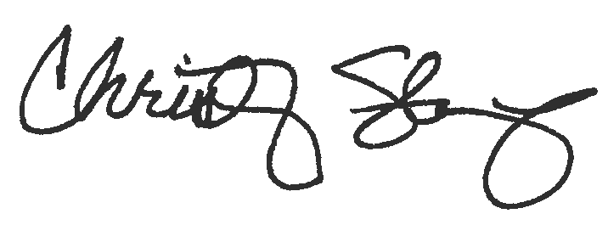
Thank you for your support.

Christy Stump

Recorder Order

Student Name__________________________________Teacher________________________

_____Please provide my child with a quality Yamaha YRS24B recorder. I have included $7.00.
Please make checks payable to GBES. Write your child’s name and “Recorder” in the
memo. No out of state checks allowed. Cash is allowed.
_____I would like to make an additional donation toward the cost of a recorder for a student
who may not be able to purchase one.

