\

Gulf Breeze Elementary Band Handbook

Table of Contents
A Letter to Parent and Students ___________________________________________________3

Finances _____________________________________________________________________4

Attendance Policy _____________________________________________________________ 4

Excused Absences _____________________________________________________________ 4

Performances _________________________________________________________________ 5

Conflicts _____________________________________________________________________5

Uniforms_____________________________________________________________________5

Personal Instruments ___________________________________________________________ 6

School Instruments _____________________________________________________________6

Approved Instrument Guide & Materials Checklist for Beginning Band ___________________7

Band Handbook Acknowledgment ________________________________________________ 8

Drop Off Guide _______________________________________________________________ 9

Dear Families,

It is my absolute pleasure to welcome you to the Gulf Breeze Elementary School Fifth Grade Band! I am so very excited to be able to share band with you this year. I started my band journey in sixth grade playing the clarinet. I continued in band through high school until it ultimately helped me to make the decision to go to college to pursue a degree in Music Education. Band is one of my passions. I have experience in working with many types of ensembles including, Concert Band, Marching Band, and Jazz Band. Currently, I am the Assistant Band Director at Gulf Breeze High School.

I have created this Band Handbook with the intention that both parent and child will have an enjoyable and positive musical experience during your involvement with the GBE Band. I have attempted to include as much information as possible about the policies and activates that are planned for this school year. With this information it is my hope that you, as a family, will be able to make a well-informed decision regarding your participation in the GBE Band.

Once you have decided that band is something you want to commit to, please return the last page of this hand book to me.

Band is a fantastic way not only to express yourself through music but to really put your knowledge to work! Playing an instrument is the best way to demonstrate all the knowledge that you have gained through music class. The musical skill and knowledge learned in elementary band is a great foundation for middle school band and beyond. It is my sincerest hope that I am not you last music teacher! Studies have shown that students with musical backgrounds often earn higher grade, score higher on standardized tests, and develop leadership and social skills that help them later in life. I am grateful to be a part of your musical journey!

If any questions arise after reading this handbook, please reach out to me at goldmanp@santarosa.k12.fl.us.

Sincerely,

Mrs. Singletary
Music Teacher
Gulf Breeze Elementary School

Finances
All members will be required to pay a one-time Band Participation Fee of $15.
This $15 will include:
- Band T-Shirt
- Music

If your student chooses to play a school instrument (more details below) there will be an additional cost of $100 to rent the instrument.

Make checks payable to Gulf Breeze Elementary School. Do not combine check with other fees (including Choir). If you are unable to pay, please speak with Mrs. Singletary.

Attendance Policy
The strength or the weakness of an extra-curricular performing group is whether the group has regular attendance from all members. You child will have band rehearsal before school at 7:30am once a week according to the schedule given when you child chooses his or her instrument (rehearsals will be on Tuesday and Thursday).

Please be sure to drop off your child at the Music Room on time but no more than five minutes early.

Closer to performance your child may be asked to attend rehearsals on both Tuesday AND Thursday morning.

Please go through your calendar and make note of these rehearsals so they do not arise as conflicts later. Minus illness, emergencies, or major events with one weeks’ notice, one hundred percent (100%) attendance is required for all members.

After two unexcused absences from band rehearsal, you child may be asked to leave the program. With so few rehearsals, it is imperative that everyone is present at all times.

Excused Absences
Only the following circumstances qualify as excused absences:
- Personal sickness,
- Death or emergency in the family,
- Prior notification presented to and excused by Mrs. Singletary at least one week prior to the event.
Please do not rely on your child or another child to be in charge of relaying information to Mrs. Singletary. Be sure that if your child must miss, a parent or guardian informs Mrs. Singletary via email, phone call, or note.

Performances
We will have several performances this year, both outside of and during school hours. One hundred percent (100%) attendance at performances is necessary. Everyone’s performance is affected when member of the ensemble are missing.

The dates and times for performances are listed below:
- December 7, 2022, Winter Band and Choir Concert
- Date TBD, Spring Band and Choir Concert
Please mark your calendars with these dates!

Conflicts
Students should be able to participate in a variety of school sponsored activities (scholastic, musical, athletic, etc.,). Great care has already been put in to avoid conflict with another school sponsored event. If there happens to be a conflict with another school sponsored event, please bring it to Mrs. Singletary’s attention. The conflict will be handled by Mrs. Singletary and the sponsor of the conflicting event.

If a conflict arises that is not due to a school sponsored event, Mrs. Singletary must be notified at least one week prior to the event or it will be counted as an unexcused absence.

Uniforms
The Gulf Breeze Elementary School Band is a unit. The students in this unit are exemplary members of our school. Students will have the opportunity to represent themselves, the band program and Gulf Breeze Elementary School at performances and in the community. It is crucial that all students in the ensemble wear the same uniform.

The uniform will be:
- Band t-shirt (included in the participation fee)
- Long blue jeans or long black pants (depending on the performance)
- Closed toed, school appropriate shoes (no sandals or heels)

Students who arrive to a performance in the incorrect attire may be charged for a band shirt ($10).

Personal Instruments
Personal instruments are defined as instruments that belong to individual students and not Gulf Breeze Elementary School. Students who choose to play flute, clarinet, or trumpet, will need to supply their own personal instrument. The student and parent/guardian are responsible for maintain the instrument in good working order. This includes having any supplies for the instrument such as reeds, mouthpieces, valve oil, cork grease, etc.

The student’s name should be on their instrument case, and any other music related item that will come to school.

On your child’s band day, your child should bring their instrument to school in the morning. The instrument will remain in the music room all day and will not be taken to their homeroom class. The music room will remain locked and/or monitored at all times throughout the day. At the end of the school day students will have the opportunity to retrieve their instrument in order to take it home.

No student will ever be allowed to hand or play another student’s instrument at school.

School Instruments
School instruments are defined as instruments which belong to Gulf Breeze Elementary School. These include baritones/euphonium and tuba. The families of students playing these instruments pay a non-refundable yearly user fee of $100. This may be split up into two $50 payments due in September and January. This fee includes an extra instrument for home practice.

The $100 user fee includes:
- Instrument maintenance
- Instrument sterilization
Repair resulting from misuse or damage by the student or student’s family must be paid by the student’s family.

No instruments will be given to students without rental fees being paid. If you have a special circumstance, please contact Mrs. Singletary as soon as possible.

Gulf Breeze Elementary School Band
2022-2023

APPROVED INSTRUMENT GUIDE & MATERIALS CHECKLIST FOR

BEGINNING BAND

The following is a list of approved brands for each instrument. The brand names on this list represent high-quality materials and workmanship. It is important that you acquire a well-made instrument in good working condition in order for your child to enjoy a successful experience in band. Besides the instrument, there are some additional items your child must have for cleaning, maintenance, and home practice, which are also listed below.

Flute
Approved Brands: Amadeus, Armstrong, Artley, Buffet, Emerson, Gemeinhardt,
Jupiter, Yamaha
Additional Materials: Essential Elements Interactive Book 1 for Flute, cleaning/tuning rod, cleaning swab, polish cloth, music stand (to be kept at home for proper practice)

Clarinet
Approved Brands: Armstrong, Artley, Backun, Buffet, Jupiter, Leblanc, Selmer,
Vito, Yamaha
Additional Materials: Essential Elements Interactive Book 1 for Clarinet, 6 Vandoren strength 2 ½ reeds, reedguard, cork grease, silk cleaning swab, mouthpiece brush, polish cloth, music stand (to be kept at home for proper practice)

Trumpet
Approved Brands: Bach, Conn, Getzen, Holton, Jupiter, King, Yamaha
Additional Materials: Essential Elements Interactive Book 1 for Trumpet,
Ultra-Pure valve oil, tuning slide grease, mouthpiece brush, snake brush, polish cloth, music stand (to be kept at home for proper practice)

Baritone/Euphonium

Instrument is rented from the school for $100 annually to help cover cleaning and maintenance costs
Additional Materials: Essential Elements Interactive Book 1 for Baritone Bass Clef, size 6 1/2AL mouthpiece (or equivalent), Ultra-Pure valve oil, tuning slide grease, mouthpiece brush, snake brush, polish cloth, music stand (to be kept at home for proper practice)

Percussion
Approved Brands: Ludwig, Pearl, or Yamaha drum and bell kit (snare drum, bells, practice pad, floor stand, sticks, mallets)
Additional Materials: Essential Elements Interactive Book 1 for Percussion

Band Handbook Acknowledgement

We, the undersigned, have read and understand the policies and procedures of the Gulf Breeze Elementary School Fifth Grade Band. This includes the finance policies, attendance policy
excused absences policy, performance policy, conflict policy, uniform policy, and instrument policy.

Both student and parent/guardian agree to abide by these policies in order for the student to remain in band this school year.

Student Name (print): ___________________________________________________________

Student Signature: ______________________________________________________________

Parent Name (print): ____________________________________________________________

Parent Signature: _______________________________________________________________

Demographic information:

Student Homeroom Teacher: _____________________________________________________

Parent Phone Number: __________________________________________________________

Parent Email Address(es):________________________________________________________

Band Shirt Order Form
(Payment for the shirt is included in the $15 Band Participation fee)

All band members will need to purchase a shirt for performances. If writing a check, please put the student’s name and “Band” in the memo field of the check. Make checks payable to Gulf Breeze Elementary School. Do not combine check with other fees (including choir). If you are unable to pay, please speak with Mrs. Singletary.

If you would like to purchase any additional shirts (duplicates, for siblings, for parents) the price is $10.

Size | Quantity
Youth Small
Youth Medium
Youth Large
Adult Small
Adult Medium
Adult Large
Adult XL
Adult XXL
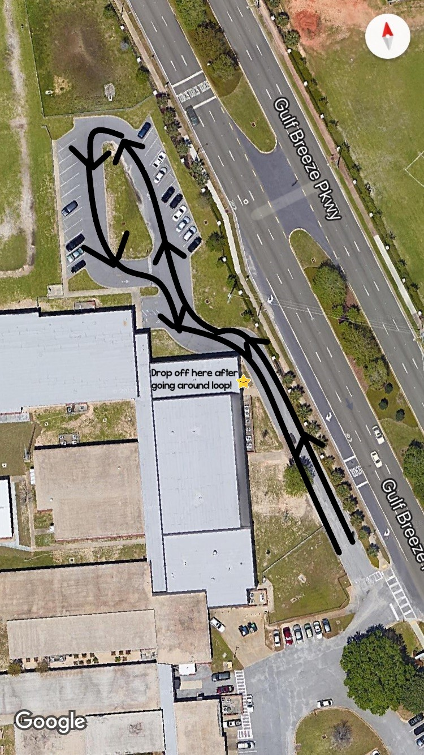
Band DROP OFF

Band drop off is near the North/4th Grade parking lot. To avoid having children cross traffic, you MUST first pass the music room, drive around the loop (shown) and then drop off your child. Please drop off your child promptly at 7:30am, and not more than five minutes before.

Please remember that all of Band is being dropped off at the same time. There will most likely being a line of cars waiting. I will do my best to help students into the music room as quickly and as safely as possible. However, patience is key!

